Maths Association report 2021-2023
ICWSONAS

Academic Year 2021-2022

Math rates 2021
Date & Time: 7th July 2021 & 10:00 AM To 11:30 AM
Venue: Through Zoom Meet

Quiz competitions are always inter
esting and informative, which provide excitement among the students.

The main objective of this event to make the aware of recent general knowledge related to Mathematics.

Department of Mathematics successfully conducted an online Quiz Competition on " Math rates 2021" on the virtual mode on 11th July 2021 for PG students.

The team of faculty members included Ms. R. Vijalakshmi, Ms. P. Bavana, Ms. K. Julaika Begum & Ms. T. Monika under the guidance of HOD , Ms. F.Patricia worked efficiently to make the competitions a grand success.

There was representation of 12 teams, each team consisting of 2 students. The Quiz began with the introduction of the Participants and rules of the Quiz were explained.

It was an interesting three round competition's consisting of Basics of Mathematics, Famous Mathematician & their Inventions and Major concepts of Mathematics. Student's were alloted 30 seconds to answer each question in three rounds. The teams were awarded 10 points for every correct answer.

Finally, third round ended with both team on the same score. Both the teams entered into tie - breaker question. Finally "Team - 7" won the competition after the tie - breaker questions.

Name if the Winners: 1. S. Keerthana, I M.Sc Mathematics
2. G. Viviliya, I M.Sc Mathematics

The Quiz was a great Success and Participants enjoyed it thoroughly.

The Quiz Programme ended successfully with National Anthem

Math Bliss 2021
Date & Time: 5th June 2021 & 11:00 AM To 12:30 PM
Venue: Through Zoom Meet

The Quiz was unique in itself because it was held on virtual platform for I UG students. There was representation of 12 teams, each consisting of 2 students.

The Quiz had three rounds. Rules and regulations of the Quiz were explained at the beginning. Three round competition's includes Basics of Mathematics, Reasoning and Problem solving. Which engaged the students for one and half hour. Winner of the Quiz Competition are Subasri S and Deepa.D. It was very informative and knowledge enriching competition's for the Participants. Virtual platform based competition's gives better experience to the participants.

National Mathematics Day
Date & Time: 22nd December 2021 & 11:00 AM To 12:30 PM
Venue: Auditorium, ICW.

National Mathematics Day was organized by final year PG students of Mathematics on 22nd December 2021 to the birthday of Shri Srinivasa Ramanujan, the great Mathematical genius who made exemplary contribution to Mathematics.

The Mathematics Day was celebrated with the objective of creating awareness about importance of Mathematics in day to day life situation and also to create students interest in studying the Mathematics.

As part of the celebration Quiz program and talk on Mathematics were organized and conducted by Ms. F. Patricia, Head of the Department.

Forty four students from B.Sc Mathematics and M.Sc Mathematics divided into 11 teams participated in the Quiz program, which was conducted in five rounds.

The winner of the Quiz Program: 1. Gnana Subasri
2. Nishwetha
3. Anupriya
4. Saraswathi

The programm was enjoyed by the Participants and other students. The students participated with great zeal &enthusiasm. In the end HR. Sr. Dr. Maria Samy awarded the Winner of Quiz Competition and encouraged the students to participate in such activities in future as well. The programm ended successfully with National Anthem
Academic Year 2022-2023

Assotion inauguration (2022-2025)
Date: 08.08.2022 @10.00 am - 11.00 am
Venue : Auditorium (icw, chinnakanganakuppam)

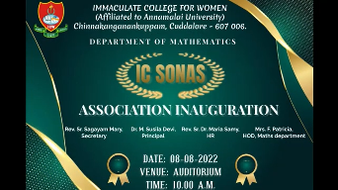

"Mathematics is not about numbers, equations, computations, 09 algorithms: It is is about understanding" "Mathematics is the best thing in this because it is true and logical world .
The ICW Mathematics Association was formally inaugurated on 08th august 2022.
The aim of this inauguration to spread awareness about the practical use of math and to inoculate love for Math students.

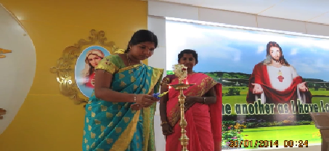

Rev. Sr. Sagayamary Natchathiram, Secretary of ICW,
Dr. Sushila Devi, a The Principal of ICW, Rev. Sr. Dr. Maria Samy, HR of ICW were invited as the chief guest. Mrs. F. Patricia, Head of the Math Department, Math faculty members and other faculty members were in attendance.
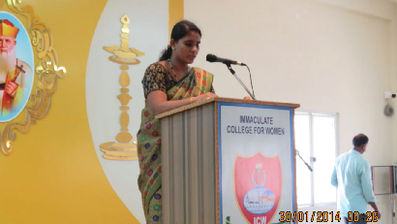

The event were hosted by Ms. Aishwariya. I and Ms. Anthuvanth Anitha. S. Prayer should always be our first response to every situation. The inauguration ceremony started with prayer song and by followed bible was recited by Ms. Ms. Agneshiya. I, III Maths ,a welcome speech delivered by followed by Ms. Kavyasree. S from III Maths. Ms. Julaika Begam announced annual report (2021).

MATH BLISS - 2022
Date: 29.09.2022 @ 11:00 AM
Venue: Auditorium (ICW, Chinnakanganakuppam)

A quiz is a quick and informal assessment of student knowledge. These quiz has three themes that are motivate students, help them remember content they just covered, and to help assess what they learned. This quiz was organized for I UG newly joined students to encourage encourage themselves. Quiz were hosted by Ms. Aishwariya · I
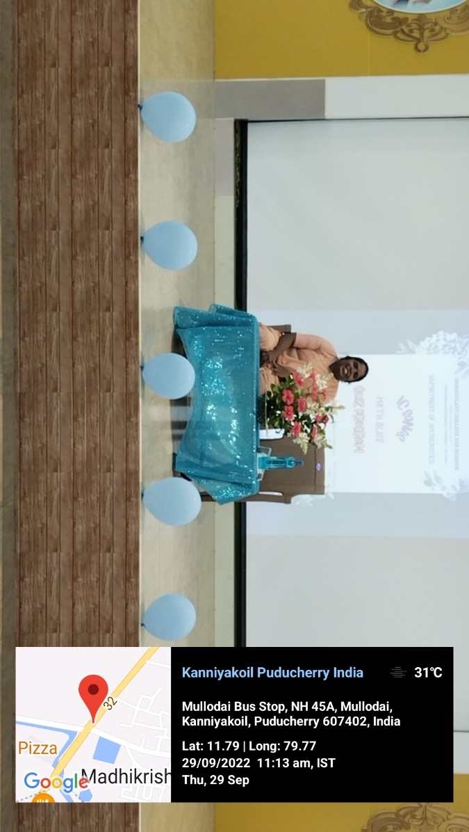
and Ms. Anthuvanth Anitha from III Maths students. It was started with prayer song
and Bible reading. Ms. Nabitha Priyadharshini from III Maths, delivered welcome address.
Followed by that quiz were started.

There were totally 13 teams. Each team had 2 students. Three rounds had conducted. In round-1, pictorial questions asked like connection game. In round-2 and round -3 , simple basic maths questions asked. Finally the winners of the Quiz program were announced.

Winners -
1. S. Arthi
2. M. Manju
Runners -
1. P. Geethapriya
2. Ms. Kiruthika
﻿
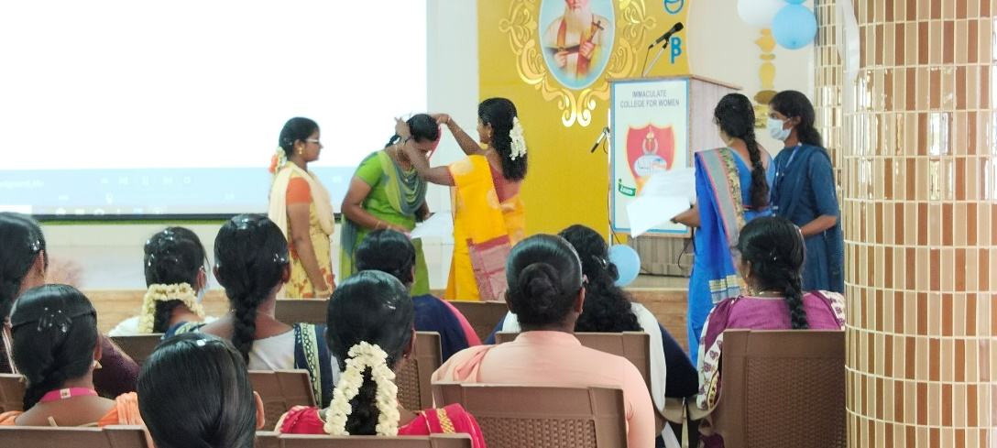

This programme was entertained by our students. Medals and Certificates were
distributed to the winner and runner Students by, MS. F. Patricia. Head,department of mathematics At this end of the session, students overjoyed, and got knoweldge
Finally the vote of thanks was read Ms. S. Kavyasree from III maths.

Math π-rates’2022
Date:11:10:2022 @ 11:30 AM
Venue: Auditorium (ICW, chinna kanganakuppam)

Quizzes can help your students practice their existing knowledge while piquing their interest in understanding a different topic.
A Quiz is a game or competition in which someone tests your knowledge by asking you questions. A quis was started at 11:30 AM on October for I PG students which was purposed to encourage them.This event were hosted by Ms. Aishwariya and Ms.Anthuvanth Anitha. A from III-Year .Program started with prayer song and Bible reading Welcome address read by Ms. S. Kavyasree

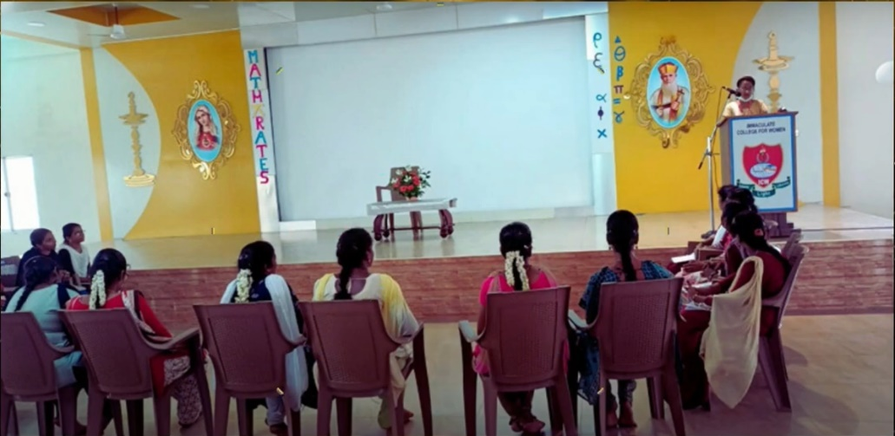

Quiz had three rounds. Students were seperated by team wise. Each team had 2 students. Participants were were enjoyed the session. Gratefully the stars of this event were announced.

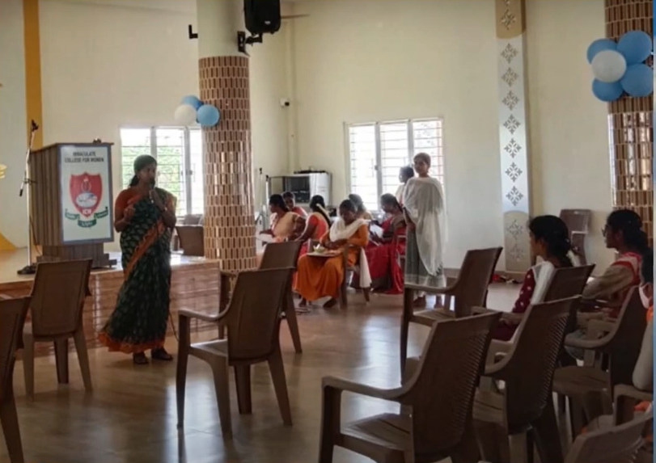

Winners:
1. Subashini. S
2. Gomathy S
Runners
1. Karthiga. E
2. Abirami. S

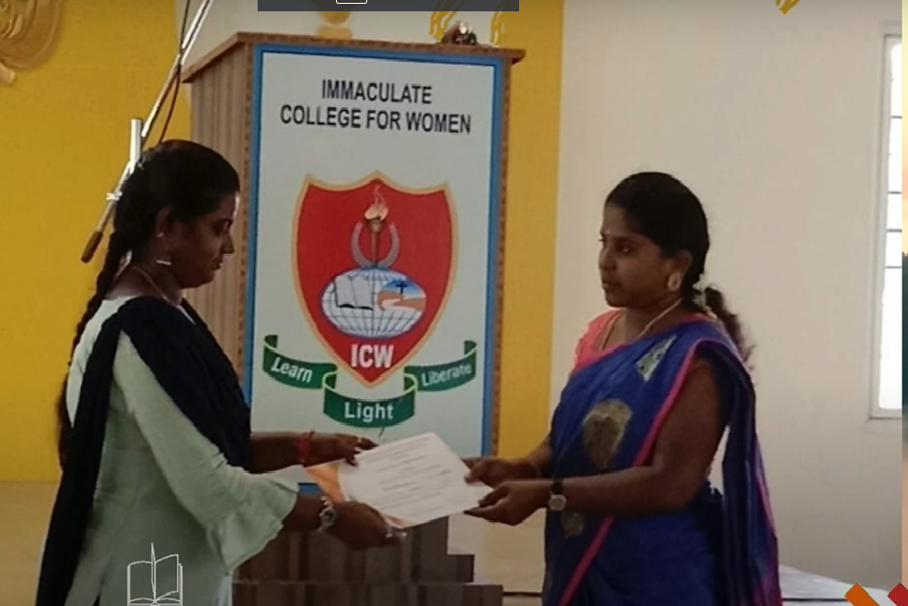

This ﻿event was entertained by our students. Winners and Rinners got medals and certificates fromMs. F. Patricia, Head,department of mathematics . Participant certificates also distributed to our students.At the end of the session, vote of thanks read by Ms. Nabitha Priyadharshine. R.B from III year student.
﻿

MATH EXPO-2023"
Date: 13.02.2023 @ 10:00 AM to 02.00AM
Venue: College Campus - Ground Floor (Room No: 001,002,003,004,005)

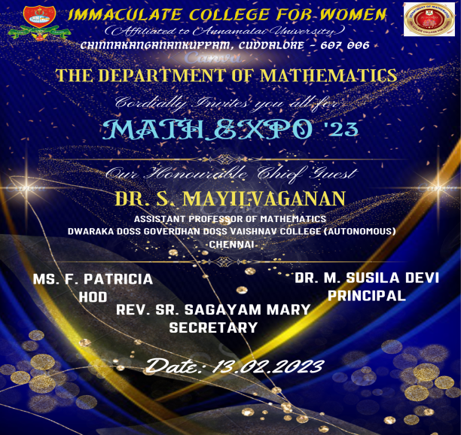

Students enjoy learning through such exhibition they put effort and make models with their hands. When they give presentations in exhibitions, they become more familiar with public speaking and this removes their stage fright and imparts self-confidence in them.
Mathematics exhibitions are very important part of the mathematics curriculum. According to that our departiment conducted. to that MATH EXPO-2023 on 13th Feb 2023 at 10:00 AM.

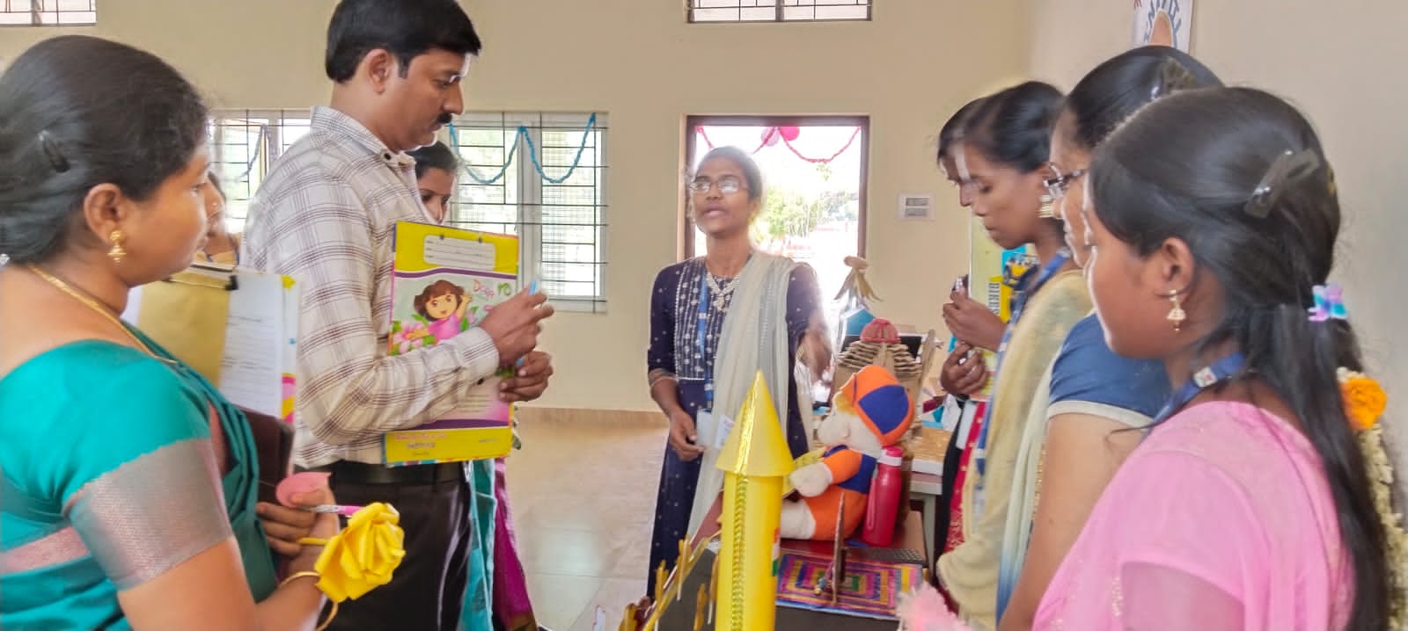

Rev. Sr. Sagayamary initiated Math Expo with ribbon-cutting. It marks to start the event successfully Dr. Susila Devi, Principal, ICW, joined to this event. UG and PG students were participated. Six teams from I year, Six teams from II year Twelve teams from III year, Six teams from I PG, Six teams from II PG.
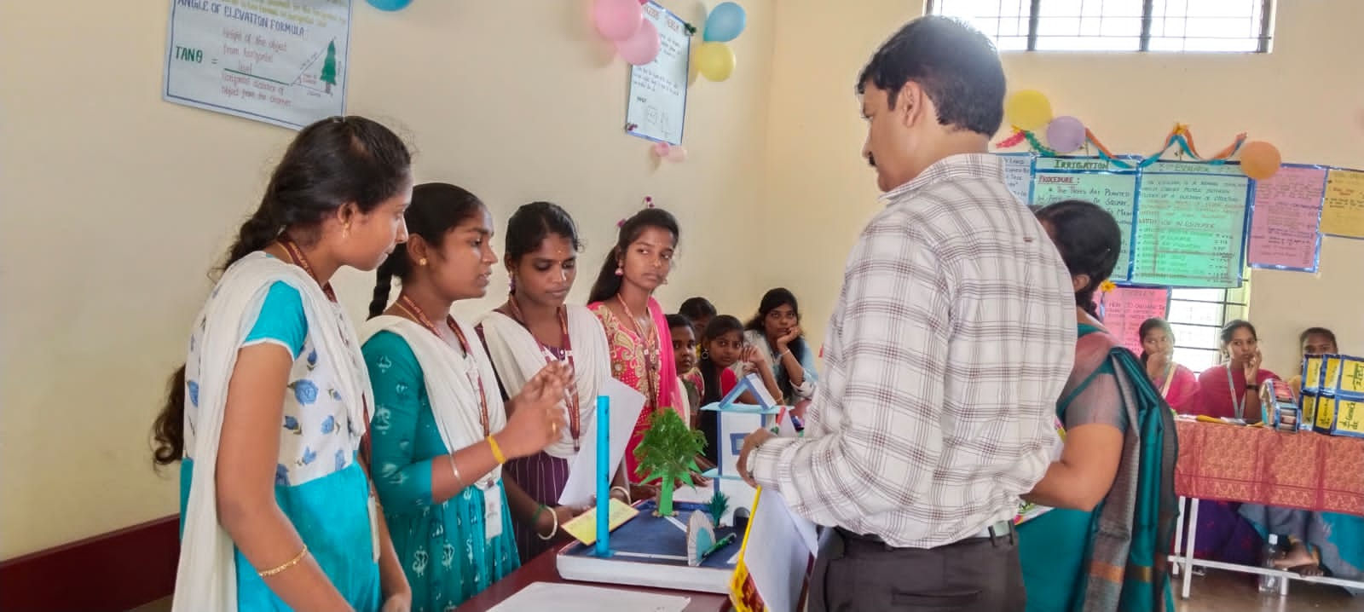

Totally 38 teams were participated. Students were presented their own idea and creativity of their models. It reflected their knowledge, explanation Skill and hardwork. Further, . F. Patricia, Head,department of mathematics,honoured our chief quest. Dr. S. Mayil vaganan, Asst. Professor, Dept. of Mathematics, Dwaraka Doss Goverdhan Doss Vaishnav College (Autonomous) Chennai. with shawl.
He was acted as a judge for this program. Finally, he selected runners and winners in each class.
﻿Students were selected by mark basis with following criteria,
- Display & Creativity
- Explanation
- Applicability and Relevance
- Content

Winners :-

I UG  1. Lakshmi. I  2. Munni begam.H.  3. Taphini Jovitha. J  4. Jenifer. M | II UG  1.vedhadharshini.V.  2. Abitha. K  3. Kaviya. B  4. Aruna. D | III UG  1. M. Mohamed salma beevi  2. G. Sadhana  3.S.Deepadharshini | I-PG  1. Hemalatha v  2. Pradeepa T  3. Karthiga. E

Runners -
I UG  1. Nandhini. M  2. Lavanya.M.  3. Pasumitha R  4. Yoga Elakiya ·M.  5. Gayathri k | IIUG  1. Thilagavathi. A  2. Lavanya. S | III- UG  1. M. Hemapriya  2. Gi Reka  3. Aysha Parveen. S.A 4.Shanmugapriya .M.  5. Pushpalatha. M | ﻿I PG  1. Midhuna. D.  2. Uma. M

Mathematics is an integral part of our daily lives. Mathematics exhibitions are organized at the colleges to help the students to understand mathematics more interestingly.This event ended with great Success.

ONLINE SEMINAR
Date:06.03.2023 @ 9:30 AM
Venue: Multi purpose seminar hall (online mode)

We, the department of Mathematics conducted seminar for both II UG and PG students were
attended the seminar.It started with a prayer song.Followed a prayer song, the chief quest address had done by Ms. R.Vijayalakshmi, Asst. Professor of Mathematics. The chief quest, Mr.Anandan Natarajan, Portfolio / Group project Manager, Capgemini Georgia, USA,
Americas INC had taken the session .
He gave some business ideas to students. Students were attracted by this confident speech.
He delivered an engaging sharing of his talk about life stories. He shared useful strategies of business, education, survival etc. Followed by him, Ms. F. Patricia, Head of the department, thanked his worthy words. Finally, the vote of thanks read by Ms. P. Geetha, Asst. Professor.

